**Red Roasted Pork Tenderloin with Balsamic Coconut Sauce**

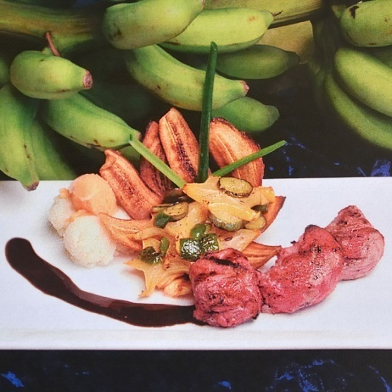

**INGREDIENTS**

**For the marinade**

4 oz Dried sorrell flower

2 cups Water

2 tbsp Coconut oil

8 oz Brown sugar

6 cloves Minced garlic

1/2 small Onion, diced

1/2 inch Ginger diced

1/2 inch ‘Fever Grass’ (lemon grass), mashed

3 tbsp White vinegar

3 lbs Pork tenderloin

2 tbsp Vegetable oil

Salt & pepper to taste

**For the sauce**

1/2 cup Balsamic vinegar, good quality

1/2 cup Coconut milk

Salt & pepper to taste

**METHOD**

**For the marinade**

1. Boil the Sorrel flowers for about 10 minutes in the water. Strain the liquid and discharge the flowers. Reduce until you have about 1 cup of liquid left and set the liquid aside.
2. ‘Sweat’ the garlic, onions, ginger, and lemongrass in the coconut oil on a low fire. They should not change color.
3. Add the sugar and let the mixture caramelize lightly.
4. Add the vinegar and the red sorrel liquid and bring to a quick boil. Let the marinade cool completely.

**For the meat**

1. Clean the pork tenderloin and cut it in 1 inch chunks.
2. Marinate the pork in the Sorrel liquid for at least 2 hours, preferably overnight.
3. Take the pork out of the liquid and dry it with paper towel.
4. Season the pork with salt & pepper and paint it with a light film of the oil.
5. Grill the pork on a BBQ grill or grill pan for about 3 minutes on each side.